Songs and Rhymes from Culture Bridge Let’s Play 15th February 2022
Hello song (Tune: skip to my lou)
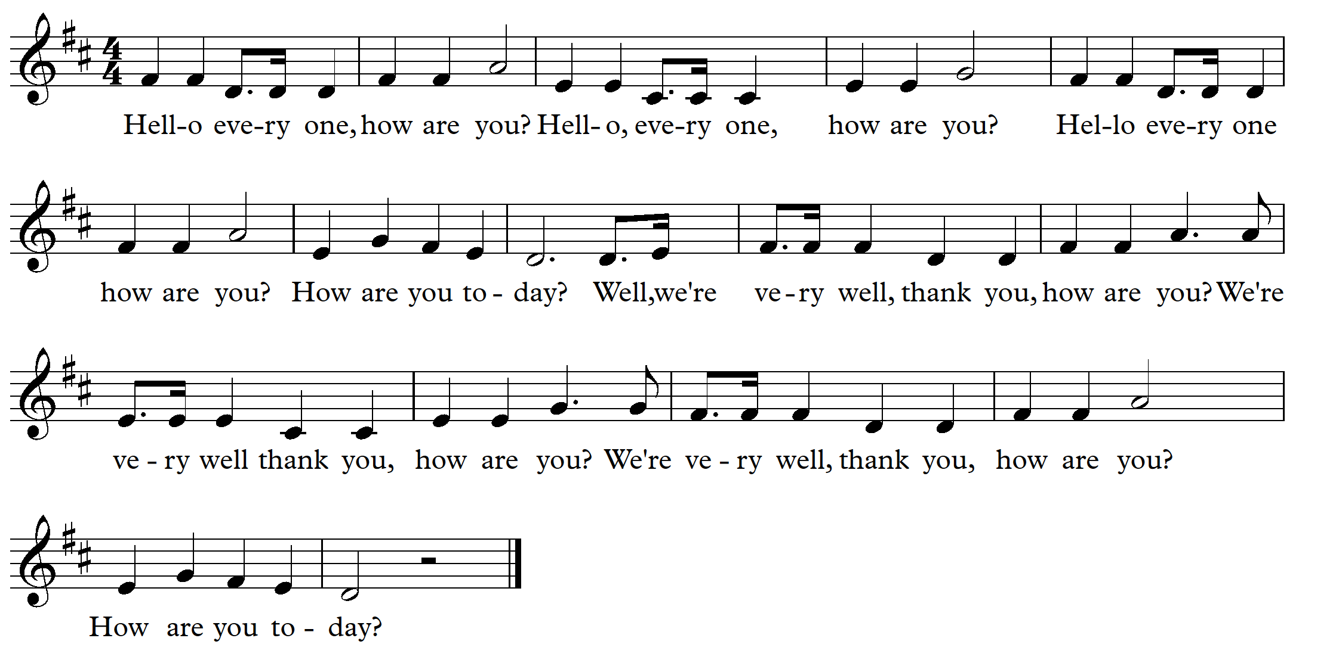
1. Sing the song using actions: Hello (wave) everyone (hands out to include everyone) how (hands palm up) are (thumbs up) you? (point outwards with two index fingers) x 3 last line how (hands palm up) are (thumbs up) you? (point outwards with two index fingers) to-day (hands down palm up twice).
2. Suggestion for other verse: Well, we’re very well thank you, how are you x3 How are you today?
3. Replace ‘everyone’ with child’s name e.g. ‘Hello, Sam, how are you? Hello, Freya, how are you? Hello, Dylan, how are you? How are you today?’ Go round the whole group.

Five little monkeys
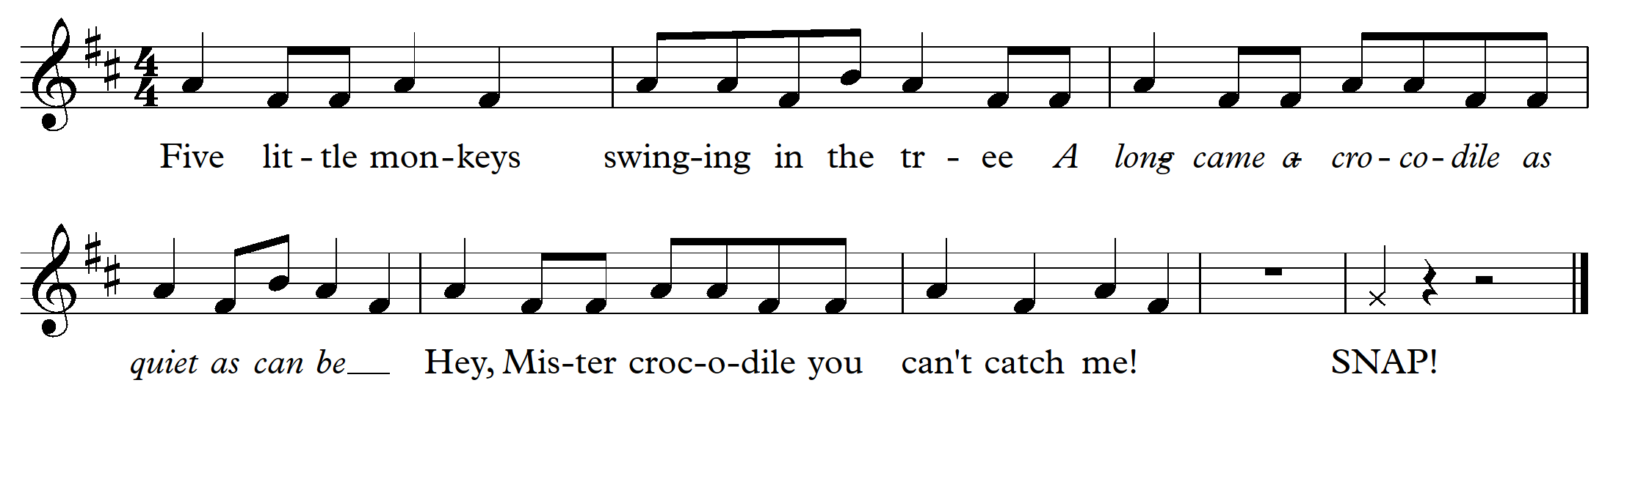1. Perform the rhyme/song with actions: Five little monkeys sitting in a tree (hold one hand up with each finger/thumb a monkey)
Along came a crocodile as quiet as could be (quiet voice, use other hand to move towards monkey hand)
‘Hey Mr Crocodile you can’t catch me’ (louder voice)
Snap! (pretend the crocodile has captured one of the monkeys)
Continue song, Four little monkeys….Three little monkeys etc. until all monkeys gone.
2. Five children to be the monkeys, one to be the crocodile, acting out the rhyme/song.
3. Use puppets to act out.
Cuckoo, where are you?
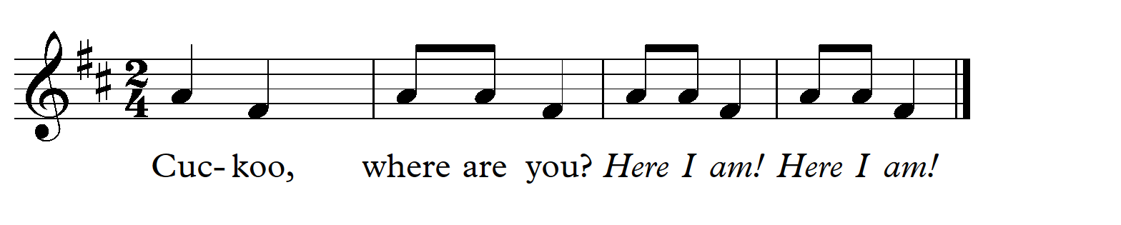
1. In a circle, a child holds the cuckoo puppet behind their back. The rest of the group sings ‘Cuckoo, where are you?’ then the child with the cuckoo brings the puppet out from behind their back and sings ‘Here I am, here I am!’
2. Child in middle of the circle with eyes closed. Give the cuckoo to a child in the circle who hides it behind their back. Everyone sings ‘Cuckoo, where are you?’ and child with cuckoo sings ‘Here I am! Here I am!’ and the child in the middle has to guess who has the cuckoo.
3. Each child has an object (teddy, ball etc). Adult sings ‘teddy, where are you?’ and child with object sings ‘here I am!’ and everyone else sings ‘I see you!’
4. Sing the register – ‘David, where are you?’ ‘Here I am!’ ‘Hello to you!’
Tidy up song (Tune: Farmer’s in the Den)
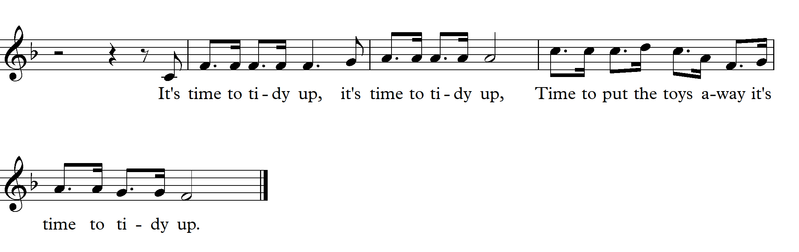
Use this song to encourage children to tidy up. It can be adapted depending on what you are doing eg ‘Time to put the blocks/paints/books away…’
Chop Chop (rhyme using speaking voice)
Chop, chop, choppity chop.
Chop off the bottom and chop off the top.
What there is left we will put in the pot.
Chop, chop, choppity chop.
1. Children sit in a circle pretending they are going to make a soup/fruit salad and put ingredients into the pot.
2. Each time a child suggests an ingredient, it has to be chopped!
3. Say the rhyme to the beat.
4. You could try big chops for larger ingredients (and use big actions) or small chops for smaller ingredients (and smaller actions).
5. Do quicker chops and slower chops depending on what you are chopping.
6. Adapt to create different things (a witch’s pot of soup for Hallowe’en, perhaps?!) and chop with different items eg knife, scissors etc.
At the end of the game, ask the children to stir the pot and say:
Stir it round, stir round.
Tell me what you have found.

