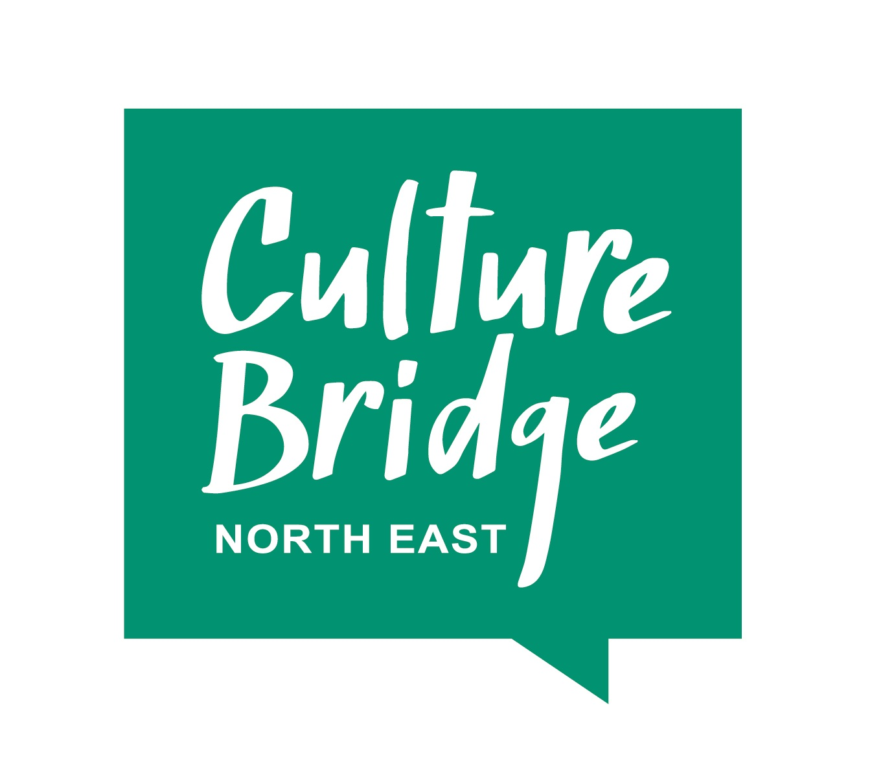
Culture Bridge North East film-maker call out

Culture Bridge North East is seeking an experienced creative film maker to document the journey of our creative schools programme, as part of the creative schools partnerships objectives.

​​Brief:

Schools are critical to young people’s access to and engagement with culture and the arts, and as such are a critical audience for CBNE. Since 2015, we have achieved a range of successes in our work with schools, and have good levels of engagement with schools across the region. There is of course always more that could be done, and in this period, we are focusing our annual additional funding, from the Department for Education, into a short-term programme working with five North East schools.
The programme asks the question: ‘How can cultural learning and access to art and culture, support issues children and young people are facing at this time?’
We know that children and young people have faced different issues and experiences over the last 18 months during the pandemic and that schools are now responding to many existing and emerging issues whilst still managing the current situation in schools. We also know that child poverty rates have increased dramatically, particularly in the North East, and some challenges and issues faced have been exacerbated, for example, school attendance, mental health and wellbeing, access to social interactions and poverty.
Through this programme we are working with five schools in the region to identify what key challenges are being faced by each school at this time and how we can collectively and creatively respond to the issues to ensure positive impacts for children and young people.
What/Who we are looking for:
We are seeking a freelance videographer or organisation with experience of creative film making to support the programme, to create five short film case studies with each school as well as a short compilation of the programme.
The films will be a crucial part in capturing pupils taking part in creative activities and opportunities as part of each school programme. Footage should include interviews with teaching staff, artists and pupils and where possible, we want to capture ‘magic moments’ of creative engagement in each school programme. The five schools are based in the North East, ranging from Sunderland to Northumberland. Travel to these schools will be a key part of the role as well as travel to cultural venues to capture students while on visits.

Purpose:

Through this commission, we’d like to address the following:

- Creatively document the highlights of the programme in each of the five selected schools.
- Bring examples to life; documenting and storytelling schools’ journeys, capturing their different experiences of the programme; the support they received, the impact it has had on their pupils and the wider impact on the school whilst hearing directly from the most important people themselves; the pupils.
- To share the film through CPD, to use digital media to document the programme and in turn, further highlight the importance of arts and cultural collaboration with schools.

Key info:

- This is a freelance contract and filming will begin in December 2021 and will be completed by March 2022.
- The successful applicant will be required to travel to different venues across the North East as part of the work.
- Applicants will be required to have a current DBS check and Public Liability Insurance.
- Deadline for quotes (with examples of your work) is 9am on Monday, 29th November 2021.

How will the resource be distributed?
It will be distributed on our social media platforms, website, newsletters and through CPD training events.

Partner credits:
All funders and partners will be credited in the finished piece, along with the credit to the successful commissioned artist.

Format and duration:
Five mini films capturing each school journey (approx 2 mins each) and a short compilation film featuring all projects.

Management of the project:
Overall, the project will be managed by the Creative Producer on behalf of CBNE.

How to apply: Please send a covering letter of no more than 1 page to bridge@twmuseums.org.uk explaining:

- How you would approach the workshop and what you hope to achieve for this project.
- Evidence of previous relevant experience which demonstrates your suitability for this work.
- Links to website/previous projects

Our Belief:

Culture Bridge North East is committed to cultivating and preserving a culture of inclusion and connectedness. We are able to grow and learn better together with a diverse team of employees. The collective sum of the individual differences, life experiences, knowledge, innovation, self-expression, and talent that our employees and contract staff invest in their work represents not only part of our culture, but our reputation. In any recruitment we undertake, we welcome the unique contributions that individuals can bring in terms of their education, opinions, culture, ethnicity, race, sex, gender identity and expression, nation of origin, age, languages spoken, veteran’s status, color, religion, disability, sexual orientation and beliefs.

If you require any further information, please email us at: bridge@twmuseums.org.uk

