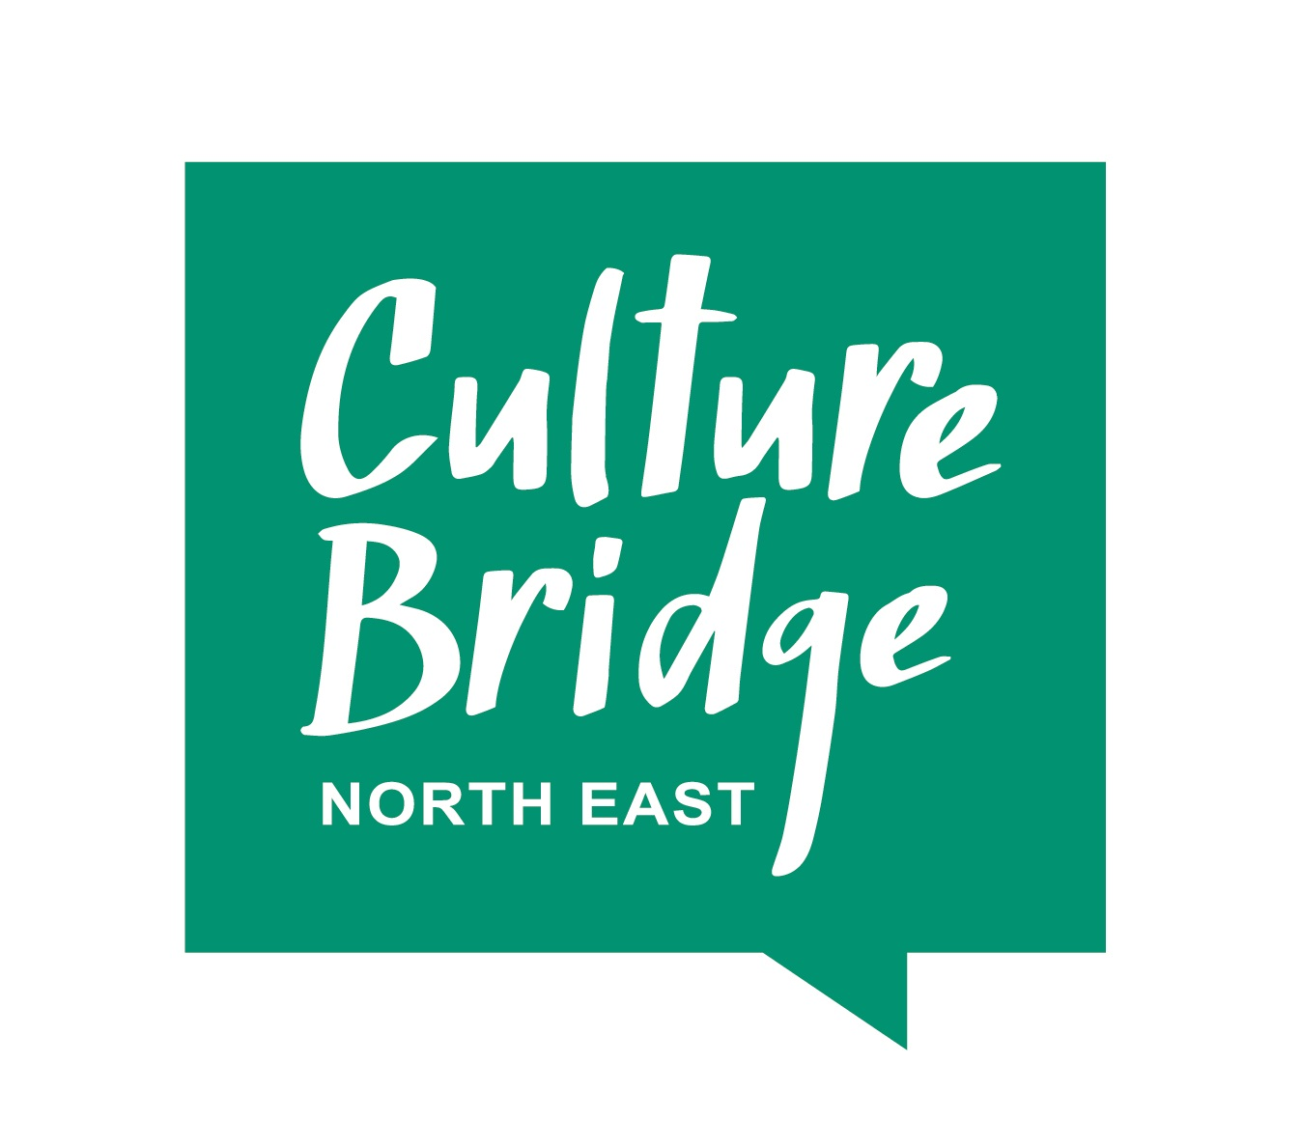
Call out for examples of effective practice in the EYFS for
Creative Classrooms: Let’s Play!

Creative Classrooms: Let’s play is our new online training programme and resource hub for early years practitioners. It will focus on developing early communication through joyful music, movement play and creative arts.

We will be launching in early January 2022.

Are you a cultural organisation with some great early years practice to share? Are you an early years teacher/practitioner in a nursery or school? Could you share your knowledge and experience of teaching creatively? Do you have a great case study of a creative collaboration to share? Are you a creative industry specialist who could deliver online creative CPD for teachers?
We will be delivering three 90-minute Let’s Play! EYFS CPD sessions, in February and March 2022. Each session will be delivered online to an audience of roughly 30 early years educators and practitioners from schools, and other early years settings in the North East. The proposal should support the theme of developing a communication rich environment through the arts.

We are looking for creatives, cultural organisations and early educators to submit proposals to input into these CPD sessions. Your proposal should be for a 20 - 60 min contribution and:

- Offer practical ideas for delegates to take away and implement with children aged 3-5.
- Give opportunities for delegates to work together and increase confidence in their creative skills.
- Demonstrate partnerships with early years practitioners and the cultural sector.
- Demonstrate links to statutory EYFS guidance, and non-statutory guidance such as Development Matters or Birth to Five Matters, depending on which has informed your practice.
- Demonstrate impact.

Making a submission

To propose a session, please send the following information:

- Who you are and how we can get in touch with you.
- The theme of your proposed session and what our audience will learn from it.
- An outline of the content.
- How you will actively engage our audience.
- Any costs.

Please submit your proposal by Thursday 18 November 2021 to: charlotte.dack@twmuseums.org.uk

If you have any questions about the programme or submitting a proposal, please email Charlotte to arrange a call.

