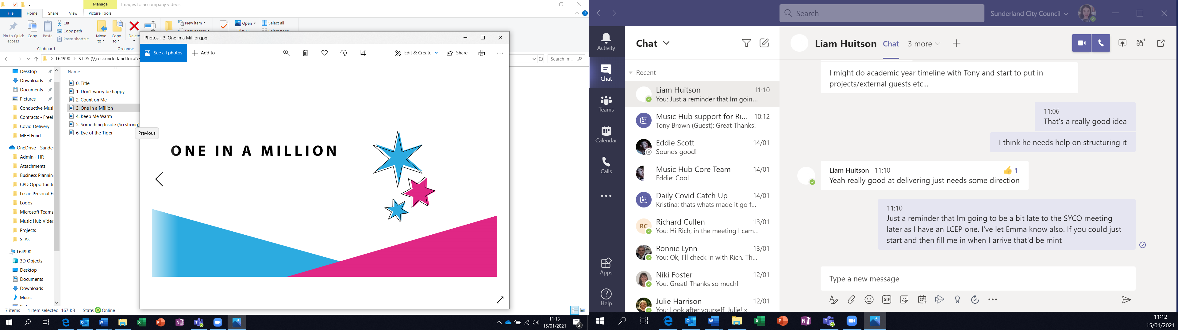
Musical Moments KS2 – Spring Week 2
Creating a Musical Story
This resource was created for Sunderland Music Hub by Laura Taylor
Listen and Respond | Can you remember the vocal warm up about the plasticine man? Follow the link to watch and join in! https://www.youtube.com/watch?v=b3rvJ747xcA
Join in and create | Let’s take the plasticine man on a brand-new musical journey!  Use the storyboard worksheet to help you create a new journey for the plasticine man.  - Decide on a little journey that the plasticine man could take.  - Break your story down into 5/6 small sections.  - Give each small section of your story a picture, description and an accompanying sound effect.
Online Resources | There are lots of interesting ways to create sounds with your body and voice. For ideas of creating sounds using your body watch this short video: https://www.youtube.com/watch?v=VOU5gAFV9v8  For ideas of creating sounds using your voice watch this short video:  https://www.youtube.com/watch?v=albDoaHTLoI&t=6s
Extension activities | The fun doesn’t end there!  - Perform your story for someone else and see if they can guess what’s happening  - Can you think of a way to illustrate your sound effect? Maybe you could add speech bubbles to your picture? Can you think of any other ways?  - Give your story to someone else without your chosen sounds and see what ideas they have.  - Why not see if you can create a longer story for a brand-new character? You could take them absolutely anywhere! Where will you go and what will it sound like?

