Expression of Interest
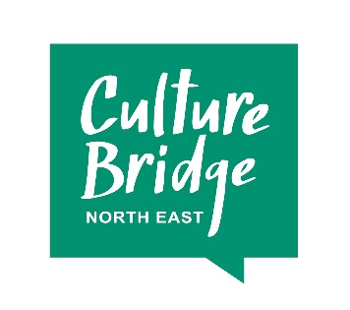
Partnership Investment 2018: Expression of Interest from Local Cultural Education Partnership (LCEP)
When submitting your form, please keep your answers concise. For the EOI we are simply asking for you to consider an idea that you would like to develop into a full application.
We will email you to let you know we have received your Expression of Interest and will let you know whether we will take your proposal forward within four weeks of submission at which point we will invite you to present your EOI to the PI Panel. If you are successful, we will work with you to develop a full budget and plan for investment in a way that best suits your ideas and proposal.
Please email your completed form to bridge@twmuseums.org.uk before 8th October 2018
Section 1: about you
Main contact name
LCEP
Phone
Email

Section 2: what do you want to do? Maximum 300 words per answer.
Which of the LCEP strategic priorities will the proposed work address and what is the planned impact?
What are you proposing to do, where and when?

Section 3: how much will it cost?
What is the total cost of the work you’re proposing to do?
How much do you need from the Partnership Investment? Remember that the minimum we can invest is £25,000.
How much will Partnership Investment help to lever in and where from? Please remember that there needs to be:
- a minimum £1 for £1 match;
- this match must be cash, not in-kind contributions;
- and must be new money into arts and cultural education in the LCEP area.
How is the other income structured, and is it already committed? If not, when do you expect it will be?

The EOI will be assessed on the following criteria:
- Does the proposal fit with regional CBNE/ACE strategy for PI?
- Does the proposed activity deliver upon the LCEP's clearly identified strategic priorities?
- Is the LCEP investable/are all PI Investable recommendations in place?
To help support the process there will be a feedback session for Applicants to meet with the PI Panel, which is currently scheduled 15.00 – 17.00 on Tuesday 6 November 2018, and gain feedback first hand on the EOI, with the opportunity to ask any further questions.

