Expression of Investment Form (EOI)
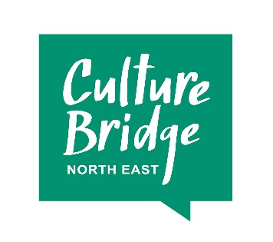
Partnership Investment 2018: Expression of Interest from Local Cultural Education Partnership (LCEP)
When submitting your form, please keep your answers concise.
We will email you to let you know we have received your Expression of Interest and will let you know whether we will take your proposal forward within four weeks of submission at which point we will invite you to discuss your EOI with the Advisory Board. If you are successful, we will work with you to develop a full budget and plan for investment in a way that best suits your ideas and proposal.
Please email your completed form to bridge@twmuseums.org.uk
Section 1: about you
Main contact name
LCEP
Phone
Email

Section 2: what do you want to do? Maximum 300 words per answer.
What are you proposing to do, where and when?

How does the proposed work align with the LCEP Strategic Plan and how do you know the work is needed?

Section 3: how much will it cost and why should Culture Bridge North East invest?
What is the total cost of the work you’re proposing to do?

How much do you need from the Partnership Investment? Remember that the minimum we can invest is £25,000.

How much will Partnership Investment help to lever in and where from? Please remember that there needs to be a minimum £1 for £1 match. This match must be cash, not in-kind contributions.

How is the other income structured, and is it already committed? If not, when do you expect it will be?

The EOI will be assessed on the following criteria:
- Does the proposal fit with regional CBNE/ACE strategy for PI?
- Does the proposed activity deliver upon the LCEP's clearly identified strategic priorities?
- Is the LCEP investable/are all PI Investable recommendations in place?
The role of the CBNE Advisory Board will be to provide advice and guidance to the LCEP through the Investment Specialist Consultant to take forward the proposal to a full application.

We will email you to let you know we have received your Expression of Interest and will let you know whether we will take your proposal forward within four weeks of submission at which point we will invite you to discuss your EOI with the Advisory Board. If you are successful, we will work with you to develop a full budget and plan for investment in a way that best suits your ideas and proposal.

