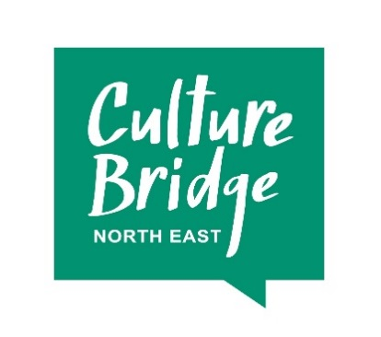

Bronze and Silver Arts Award Peer Mentoring Programme
Information and application form
The Customs House, on behalf of Culture Bridge North East, are seeking applications to recruit up to 15 current Arts Award advisers (at Bronze and Silver levels) committed to developing their understanding and experience of Bronze and Silver Arts Award. This is a high profile programme to support embedded practice and progression through Arts Award levels. The process will be captured through the creation of a film.
Applications are welcomed from current arts and culture sector trained Advisers with low to medium levels of confidence, experience and knowledge in Arts Award Bronze and Silver. All participants must already be trained Advisers in Bronze and Silver as Adviser training will not be included. However, there will be a refresher element to provide a reminder of the Arts Award criteria and process.
Programme participants will be part of an action learning based Peer Mentoring Programme, focussed on gaining confidence in planning and delivering Arts Award at Bronze and Silver levels in their own settings. Each participant will have an assigned mentor for one-to-one support as well as benefiting from group peer-to-peer support through the network of other participants and the Customs House and Culture Bridge North East teams.
There is no expectation that Advisors will take young people through to moderation in the course of the programme, but places will be prioritised for people who show commitment to delivering Arts Award after completing the programme.
The programme will begin with a half-day refresher for Bronze and Silver Arts Award, followed by introductions to allocated mentors. Using the structure of the Bronze Arts Award, participants will begin to create their own plans using an Arts Award portfolio template. Participants will then further develop their understanding of Bronze Arts Award by working through the Award process with their mentor to map an existing project or delivery method in their organisation.
There will be a mid-point half day session, providing an opportunity for Advisers and mentors to come together again and reflect on their project as well as spending time planning a Silver Level Award. There will be a final sharing event in January 2018 to reflect on participants’ project developments and plans, and watch a film which will have captured the participants’ experiences throughout the programme. The film will be shared with the wider arts and culture sector to support others so participants will be contributing to a region wide learning resource.
If you are interested, please complete the application form and send it to Fiona Martin, Learning and Participation Manager at The Customs House: Fiona@customshouse.co.uk no later than 12pm on Friday 16 June 2017.
Please contact Fiona if you have any questions or queries.

Bronze and Silver Peer Mentoring Programme Application Form
Name:
Organisation:
Contact Email:
Arts Award Adviser status (this information will help us partner participants to mentors)
All participants must already be trained Bronze and Silver Advisers. When did you complete your training (approximately)?
Where would you place your confidence level around your knowledge and experience in Bronze and Silver Arts Award – low, medium or high? Please explain your answer
In brief, what is your direct experience of delivering Arts Award (any level) as an Adviser? Please include which levels you have had successfully moderated, as well as indicating the numbers.
Interest in this programme
Why are you interested in this opportunity and what would you hope to gain from this?
What would delivering Arts Award at Bronze and Silver Level mean to you and your organisation?
Are you committed to delivering Bronze and Silver Arts Award as a result of participating in this programme? Please tell us about any plans/ideas/approaches you are currently considering if any (understanding that participating in the programme will support you in developing these further):
Are you happy to be filmed and provide evaluation and comments as a participant in this programme?
Do you have any specific dietary or access requirements? (this will not affect your application success, it is to aid appropriate allocation of spaces and catering for the sessions throughout the programme)

