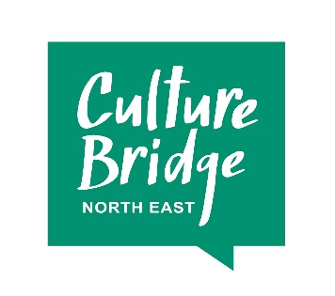
Partnership Investment 2017: expression of interest
When submitting your form, please keep your answers concise and supply a business plan and budget if available.
We will email you to let you know we have received your Expression of Interest and will let you know whether we will take your proposal forward within four weeks of the deadline. If you are successful, we will work with you to develop a full budget and plan for investment in a way that best suits your ideas and proposal.
Please email your completed form to bridge@twmuseums.org.uk by 5pm on:
3 July 2017, or
2 October 2017.
Section 1: about you
Main contact name
Organisation name
Organisation type (e.g. theatre, school, library etc)
Address
Phone
Email
Website or social media pages

If you plan to work in partnership with any other organisations, please list them here and describe their role.

Section 2: what do you want to do?
What are you proposing to do, where and when?
How many children and young people will be involved and in what way?
What specific outcomes and impact will you achieve for children and young people (please tell us in as concrete, clear and measureable a way as possible)?
How will you use the other Arts Council England resources (Arts Award, Artsmark, the Quality Principles)?
How do you know the work is needed? You must provide evidence which demonstrates need and/or demand for the work.

Section 3: how will our investment lead to sustainable activity?
Tell us what happens when the money runs out. How will this work make sustainable improvements to cultural education for children and young people, beyond the life of our investment?
We understand this could happen in a number of ways, in relation to the outcomes you achieve, the programme you establish, the ways of working or services you put in place.
How will you enable others to learn from what you do? This might be about the work that you deliver, but we are also interested to share new and innovative models for financial or operational sustainability.

Section 4: how much will it cost and why should Culture Bridge North East invest?
What is the total cost of the work you’re proposing to do?
How much do you need from the Partnership Investment Challenge? Remember that the minimum we can invest is £25,000.
How much will the Partnership Investment Challenge help to lever in and where from? Please remember that this has to be income that has not been previously spent on cultural activity with children and young people, and that there needs to be a minimum £1 for £1 match. This match must be cash, not in-kind contributions.
Why do you need the Partnership Investment Challenge to help lever in the new income?
How is the other income structured, and is it already committed? If not, when do you expect it will be?

